Cross Crawl Exercise Resources
Cross crawl refers to movements in which we use opposition such as crawling, walking, running, and swimming. Opposition means that opposite sides of the body work together to coordinate the right arm and left leg, then the left arm and right leg.
Therapeutically, cross crawl refers to any intentional cross-lateral activity in which you cross the mid-line of the body, such as touching opposite hand and knee or foot. Performing this movement builds the bridge between the right and left hemispheres of the brain, allowing for electrical impulses and information to pass freely between the two, which is essential for physical coordination as well as cerebral activities, such as learning language, reading, and hand-to-eye coordination.

https://www.yourtherapysource.com/blog1/2019/06/16/cross-crawl/
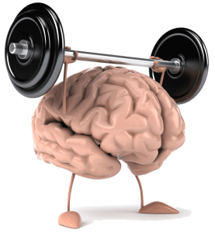
cross-crawl technique is one of the easiest ways to activate your brain development and nervous system. It is essentially an exaggerated walk which facilitates the crossover of energy between the left and right hemispheres of the brain. Signs that your cross-pattern movements could use some sharpening include:
- Lack of coordination and balance
- Difficulty reading
- Exhibiting learning disabilities, such as dyslexia
- Clumsiness
- Saying things backwards

http://www.kinesiologyzone.com/cross-crawl-increase-mind-power/

Brain Gym Exercise 3 – Cross Crawl
https://www.loveyourbrain.org.hk/en/428/3-brain-gym-exercise-3-cross-crawl
Exercises for Cross-Lateral Connectivity
https://www.charlottewattshealth.com/exercise/exercises-cross-lateral-connectivity/

BrainDance is a full body-brain exercise based on developmental movement patterns that healthy human beings naturally move through in the first year of life. “The mind is like the wind and the body like the sand; if you want to know which way the wind is blowing, you can look at the sand.”
~Bonnie Bainbridge Cohen
https://www.creativedance.org/about/braindance/

